**CASE REPORT**

**NON METALLIC ANTERIOR CHAMBER FOREIGN BODY:**

**A CASE REPORT**

**Nabilah Afifah1, Nina Handayani 2, Triana Budi Sulistya2**

*1* *Resident, Department of Ophthalmology, Faculty of Medicine, Universitas Brawijaya, Dr. Saiful Anwar General Hospital.*

*2* *Cataract and Refractive Surgery Department, Department of Ophthalmology, Faculty of Medicine, Universitas Brawijaya, Dr. Saiful Anwar General Hospital*

*Email : nabilaffh@gmail.com*

# **ABSTRACT**

***Introduction:*** *Intraocular foreign body (IOFB) is a serious form of open-globe injury that can cause a serious ocular trauma that lead to blindness (10–40% of all open eye injuries). This case report is aimed to report a challenging management of anterior chamber foreign body.*

***Case Report:*** *A 41 year-old man presented with discomfort on his right eye 4 days prior to visit. The slit lamp biomicroscopic examination revealed inferior anterior chamber foreign body (stone), measuring 5 x 2 mm and 5 mm scar at the area of a full thickness self-sealed corneal laceration. The corneal edema was localized hence it was possible to visualize the foreign body’s entire path through the cornea. The foreign body was removed with forceps from superior limbal incision. Post operative visual acuity was improved and the inflammation was decreased.*

***Discussion:*** *Management of such cases is not always easy because certain ACFB made of inert materials (stone, plastic, glass, and inert metals such as gold, silver, or platinum) excite minimal inflammation and may remain quiescent for a long period of time. An anterior IOFB is usually associated with a better final BCVA than a posterior IOFB. The self-sealing wounds were limited to the paracentral or peripheral cornea, resulting in no significant astigmatism*

***Conclusion:*** *The risk of intraocular foreign body is associated with mechanism of injury and history taking must be accurate. Intraocular foreign bodies must have surgical removal to prevent of ocular inflammation and complication.*

***Keywords:*** *Anterior Chamber Foreign Bodies (ACFB), IOFB, Open Globe Injury, Penetrating Injury.*

**INTRODUCTION**

IOFBs are the worldwide problems and represent a serious form of open-globe injuries that can result in visual loss. Intraocular foreign bodies (IOFB) cause a serious ocular trauma that can lead to blindness (10–40% of all open eye injuries). IOFB is closely related to the living and working environment, as well as the individual awareness of protection and protective measures. 1,2

The most eye injuries with IOFBs are work related. The three most common causes of eye injuries were grass trimming, chiselling, and hammering. 3 Penetrating ocular trauma is a potentially vision-threatening injury. The extent of injury depends on factors that include size and composition of the foreign body, force of entry into the eye, location of the resulting wound, and the final location of the foreign body. Other important factors that might influence the final prognosis are initial visual acuity, presence of an afferent pupillary defect, perforation of the globe, and endophthalmitis.4

We report a case of an adult male with a retained intraocular stone foreign body in the anterior chamber of the eye and discuss the various considerations in the management of such cases.

**CASE ILLUSTRATION**

A 41-year-old man was referred to the outpatient clinic of the Cataract and Refractive Surgery Department in Dr. Saiful Anwar Hospital, Malang, Indonesia, with discomfort in his right eye (RE) for the past 4 days while hammering the stone. The patient had a past history of ocular trauma to the left eye (LE) while hammering stone four days before his visit. He didn’t wear any protective glasses at that time. The patient was treated by local ophthalmologist using amoxicillin 500 mg t.i.d., sodium diclofenac 50 mg b.i.d., gatifloxacin q.6h, a combination of hydrocortisone acetate 5 mg and chloramphenicol 2 mg eye drop q.6h on RE for 4 days. There was no improvement, but a detailed examination revealed a foreign body, and he was referred to our hospital for further evaluation and management.

The chief complaint was accompanied by redness, blurred vision, and watering on his RE. There were no complaints of nausea or vomiting. In his past medical history, there was no significant eye disease, history of previous eye surgery, or history of systemic disease.

Upon examination, the patient’s best corrected visual acuity (BCVA) was 6/30 for the RE and 6/6 for the LE. In the RE, there was a 5 mm of a full thickness self-sealed corneal laceration proven by negative seidel test. Slit-lamp examination showed anterior chamber single black foreign body (FB) residing in the angle inferiorly (Figure 1). Inflammatory reaction showed inferior corneal oedema, conjunctival injection, pericorneal injection cornea,. The iris sphincter was regular. Moderate anterior chamber reaction was found (flare +2 and cell +3). The pupil showed a slightly non-round diameter of 4 mm, sluggish pupillary reflex, and negative RAPD. Lens was clear (Figure 2). The intraocular pressure (IOP) was 20 mmHg for the right eye. The anterior and posterior segments of the left eye were normal.

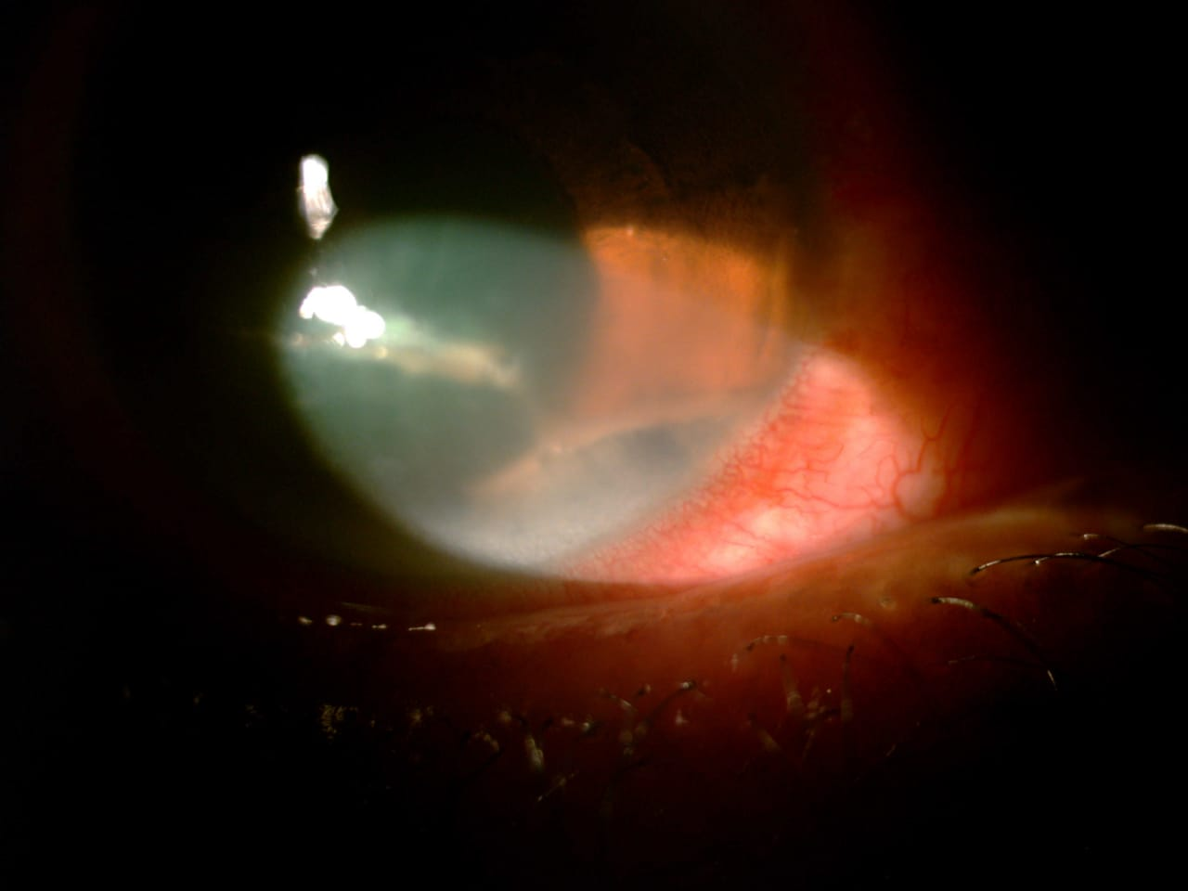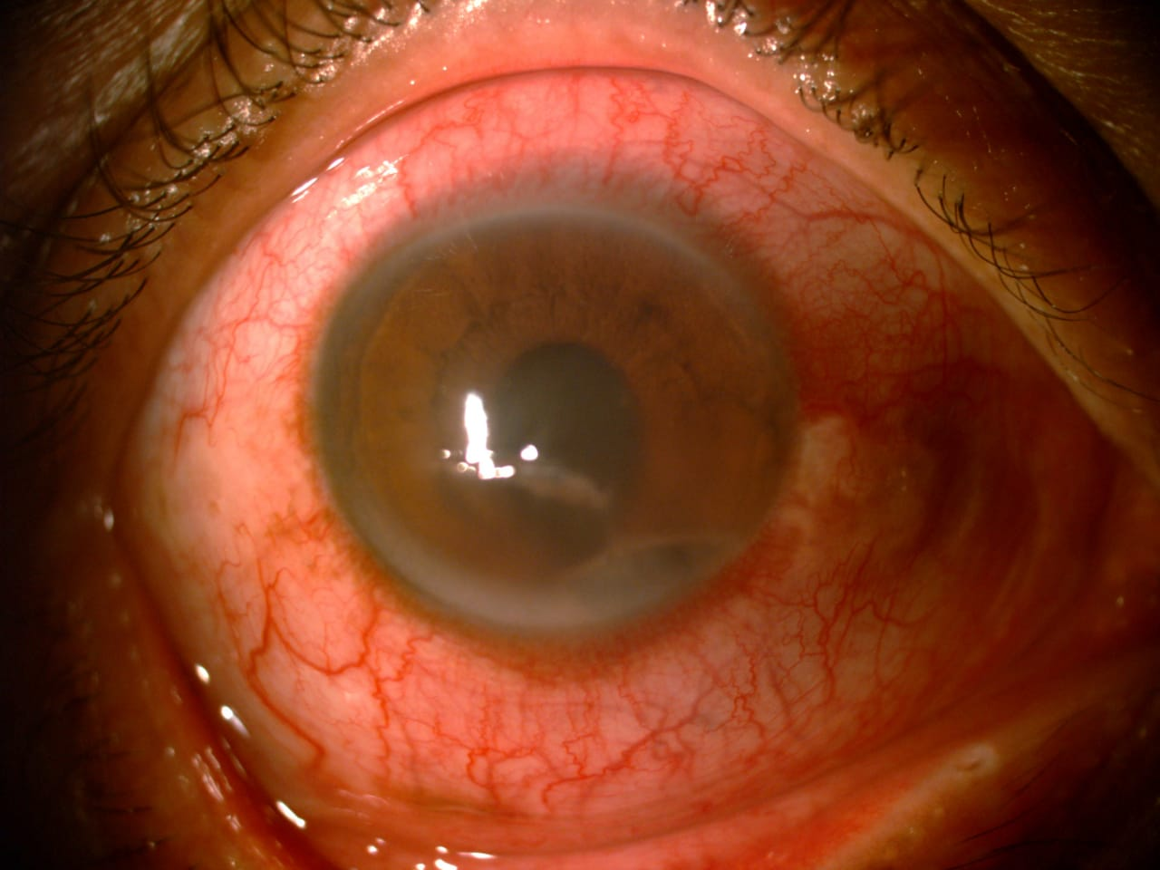

**B**

A

**Figure 1.** Anterior segment of RE : **A**. Ocular surface of the RE showing macula cornea (blue arrow) and anterior chamber foreign body (white arrow). **B**. Anterior chamber foreign body in 25x magnification.

**Figure 2.** Clear lens showed no injury to the lens.

The ultrasound B scan reported no acoustic shadowing or reverberations, as would be expected. B-scan ocular ultrasonography of the posterior segment for the RE showed a clear vitreous cavity with an attached retina in both eyes and did not reveal any abnormality in the posterior segment (Figure 3). The patient was diagnosed with an anterior chamber foreign body (ACFB).

**Figure 3.** Ultrasound B scan did not reveal any abnormality in the posterior segment.

The ACFB was planned to be removed surgically with local anaesthesia. Levofloxacin eye drop q.4h and 1% atropine sulphate eye drop q.8h are given as preoperative medicine.

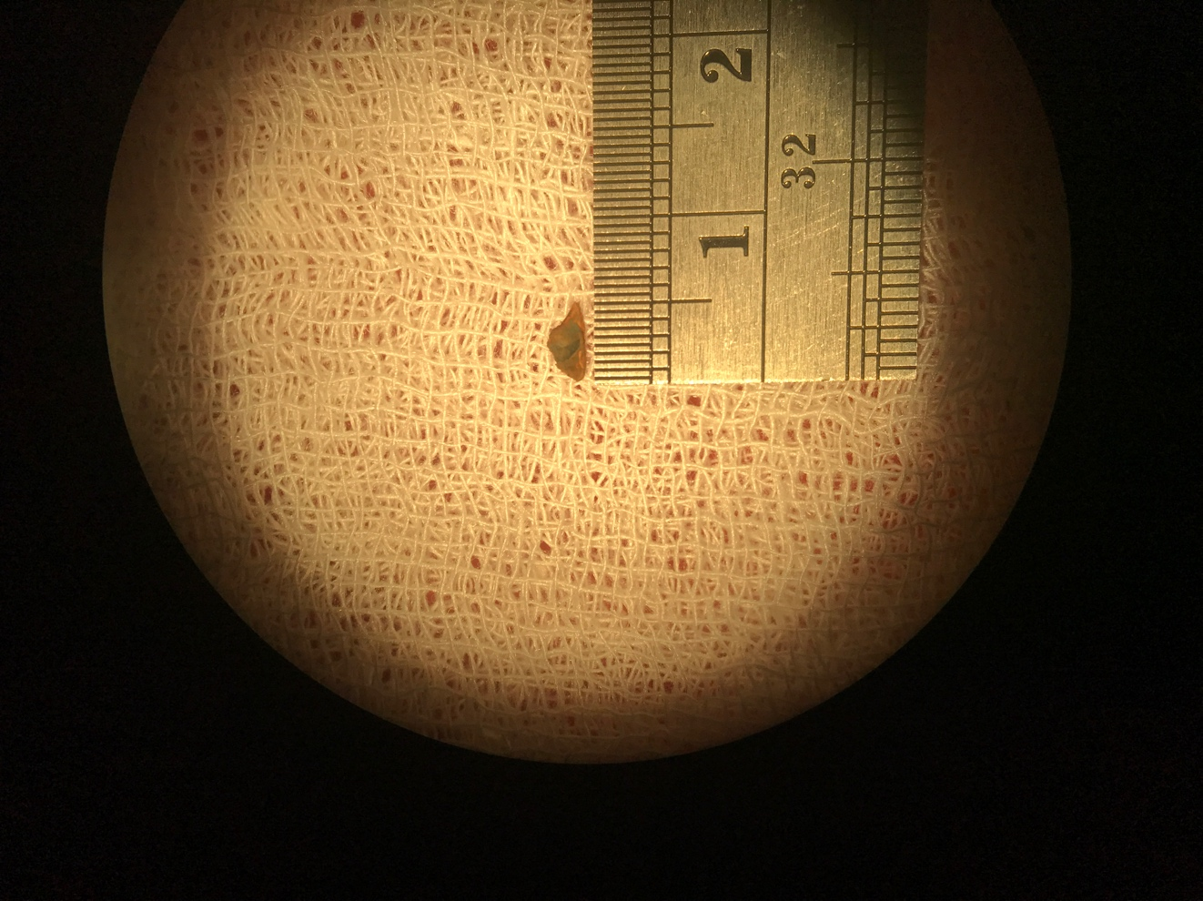The superior limbus incision was made at 5 o’clock with a 2.8 mm keratome blade. The anterior chamber was filled with 2% methylcellulose, and the foreign body (Figure 4) was removed *in toto* with forceps. The remaining refractile particles were aspirated out with irrigation and an aspiration instrument Intracameral cefuroxime was given before suturing and incision was then closed with 10-0 nylon.

**Figure 4.** The size of the removed stone was 5 x 2 mm.

During postoperative period, the patient was given oral ciprofloxacin 500 mg b.i.d., oral paracetamol 500 mg t.i.d., oral metilprednisolon 8 mg t.i.d., topical levofloxacin eye drop q.4h, and atropine sulphate eye drop q.8h on RE.

The first day postoperatively, RE visual acuity was decreased to 6/60 due to corneal edema (Figure 5). Conjunctival injection, pericorneal injection, and two sutures with a negative seidel test at the superior limbus were noted. Flare +2 and cell +3 were seen in the anterior chamber. The pupil was not round with a negative pupillary reflex due to cycloplegia. The intraocular pressure was 18 mmHg. Fundus examination was performed post-operatively, and there wasn’t any retained intraocular foreign body, and the detail was normal.

**Figure 5.** Day 1 post-op: corneal edema with conjunctival and pericorneal injection.

One week after the surgery, RE visual acuity had improved to 6/12 with a correction of S-1.00 C−4.00 ×60. Reduction of conjunctival injection, pericorneal injection, and corneal edema was significant (Figure 6). Anterior chamber flare and cell were negative. Pupil was still not round with a negative pupillary reflex due to cycloplegia. Intraocular pressure was 16 mmHg and the posterior segment was within the normal limit.

**Figure 6.** 1 week post-op: corneal edema, conjunctival, and pericorneal injection were reduced.

Two weeks after surgery, RE VA improved to 6/6 with a correction of C−3.00 ×60. Conjunctival injection was minimum and there was negative anterior chamber reaction (Figure 7). The pupil was still not round with a negative pupillary reflex due to cycloplegia. Intraocular pressure was 14 mmHg and the posterior segment was normal.

**Figure 6.** 2 week post-op: corneal edema, conjunctival, and pericorneal injection were significantly reduced.

**DISCUSSION**

Intraocular foreign body, a kind of ophthalmic emergency, accounts for about 6 % of the ocular trauma and is commonly seen in young male. Splashing of foreign bodies appears most commonly during hammering the foreign object; polishing, welding, drilling, and so forth are also common situations. The IOFBs is one of the leading causes of monocular blindness. The longer foreign bodies stay in the eyes, the greater damage they make. For those reasons, early diagnosis and treatment of IOFBs is important. 1,5

AC FBs are rare accounting for only 15% of all intraocular IOFBs. Common ACFBs include metallic iron, lead, copper, and nonmetallic FBs such as stone, glass, plastic, cilia, wood, or other vegetative matter. The nonmetallic FBs often have a lower velocity and tend to remain in the AC.6

Our patient had a stone foreign body entering through the cornea and resting in the inferior angle making it difficult to detect on slit-lamp examination. Therefore, after taking a thorough history of any ocular or orbital trauma, foreign body must be ruled out even when not observed on initial examination.

The CT scan with thin slices is currently considered the gold standard for the detection, localization, and characterization of both metallic and non-metallic IOFBs. Ultrasonography can be used to detect metallic IOFB but sensitivity is user dependent. It is also contraindicated in cases where globe rupture is suspected. Plain X-ray may be used as a screening modality for IOFBs. MRI is contraindicated in cases of suspected metallic IOFB. It may be considered when there is a strong suspicion of a non-metallic foreign body not seen with CT scan or ultrasonography.7

Primary removal of a small nonmagnetic foreign body can be very challenging. Once the decision to remove is made, surgery should be performed as early as possible.8 Removal of ACFB through the entry wound is generally not recommended. Foreign body was removed using an intraocular magnet or forceps through a secondary corneal limbal incision, which can also be used for the removal of intralenticular foreign bodies.9

In this case, incision was made at superior limbus because it gave surgeon easier access. Sinskey was firstly used to release the FB from the surrounding tissue. It was hard to release because of the surrounding inflammatory membrane. FB was removed from anterior chamber with forceps after widening the wound. Repeated viscoelastic injections were given during the procedure to maintain its stability and to protect corneal endothelium.

Intracameral cefuroxime was given before closing the wound. Bowen, et al. reported that intracameral cefuroxime and moxifloxacin reduced endophthalmitis rates compared to controls with minimal or no toxicity events at standard doses. 10

Management of such cases is not always easy because certain ACFB made of inert materials (stone, plastic, glass, and other metals such as gold, silver, or platinum) excite minimal inflammation and may remain quiescent for a long period of time. Furthermore, decreased visibility through the cornea due to severe whole corneal edema and lots of KPs with pigmentation imposes an even greater challenge for many surgeons in ACFB removal procedures. 11 In other journal, *Jastaneiah, et al.* reported despite the long duration of the corneal edema it resolved after removal of the FB, the endothelial damage will always be there. 12 In this case, the corneal edema was appeared 1 day after surgery and reduced in one week.

Clinicians administer antibiotics, such as third and fourth generation fluoroquinolones for 7 to 10 days following surgery as prophylaxis against post-traumatic endophthalmitis.13 We gave ciprofloxacin in this case as a prophylaxis and we added methyl prednisolone to reduce inflammation.

An anterior IOFB is usually associated with a better final BCVA and prognosis than a posterior IOFB. The self-sealing wounds were limited to the paracentral or peripheral cornea, resulting in no significant astigmatism. 14 The Ocular Trauma Classification Group has developed the Ocular Trauma Score (OTS) system to help the ophthalmologists prognosticate the outcomes of eye trauma, OTS show 77% chance to predict the final functional outcome within one visual category shortly after the eye injury.15 Ocular Trauma Score (OTS) in this case has a prognosis of visual acuity were 94% ≥20/40 and the visual acuity after one week surgery was improved

**CONCLUSION**

In conclusion, prognosis of anterior chamber foreign body is greatly associated with mechanism of injury and accurate history-taking. Anterior chamber foreign bodies must be removed surgically to prevent further ocular inflammation and complication.

**REFERENCES**

1. Li L, Lu H, Ma K, Li YY, Wang HY, Liu NP. Etiologic causes and epidemiological characteristics of patients with intraocular foreign bodies: retrospective analysis of 1340 cases over ten years. Journal of ophthalmology. 2018 Jan 31;2018.
2. Chang T, Zhang Y, Zhang K, Zhang X, Wang M, Zeng Y, Zhang M. Epidemiology, clinical characteristics and visual outcomes of patients with intraocular foreign bodies in Southwest China: A 10-year review. Ophthalmic Research. 2020 Nov 13.
3. Ratanapakorn T, Kongmalai P, Sinawat S, Sanguansak T, Bhoomibunchoo C, Laovirojjanakul W, Yospaiboon Y. Predictors for visual outcomes in eye injuries with intraocular foreign body. Clinical Ophthalmology (Auckland, NZ). 2020;14:4587.
4. Graffi S, Tiosano B, Ben Cnaan R, Bahir J, Naftali M. Foreign body embedded in anterior chamber angle. Case reports in ophthalmological medicine. 2012 Jan 1;2012.
5. Yan H, editor. Mechanical ocular trauma: current consensus and controversy. Springer; 2016 Oct 31.
6. Menon S, Kumar PS, Pai HV. Rare foreign bodies encountered in ophthalmic practice. Journal of Clinical Ophthalmology and Research. 2021 Jan 1;9(1):34.
7. Al-Tamimi ER. A peculiar case of a retained inert piece of fireworks as an intraocular foreign body in the anterior chamber. Saudi Journal of Ophthalmology. 2014 Jul 1;28(3):225-7.
8. Su Z, Wang Y, Yi Q, Lin L, Lai K, Ye P, Wang Y, Fang X. Clinical Characteristics and Visual Outcomes in Patients with Intralenticular Foreign Bodies with Self-Sealing Corneal Penetrating Wounds. Journal of Ophthalmology. 2021 Jun 22;2021.
9. Liu Y, Wang S, Li Y, Gong Q, Su G, Zhao J. Intraocular foreign bodies: clinical characteristics and prognostic factors influencing visual outcome and globe survival in 373 eyes. Journal of ophthalmology. 2019 Feb 13;2019.
10. Bowen RC, Zhou AX, Bondalapati S, Lawyer TW, Snow KB, Evans PR, Bardsley T, McFarland M, Kliethermes M, Shi D, Mamalis CA. Comparative analysis of the safety and efficacy of intracameral cefuroxime, moxifloxacin and vancomycin at the end of cataract surgery: a meta-analysis. British Journal of Ophthalmology. 2018 Sep 1;102(9):1268-76.
11. Huang YM, Yan H, Cai JH, Li HB. Removal of intraocular foreign body in anterior chamber angle with prism contact lens and 23-gauge foreign body forceps. International journal of ophthalmology. 2017;10(5):749.
12. Jastaneiah SS. Long-term corneal complication of retained anterior chamber-angle foreign body. Saudi Journal of Ophthalmology. 2010 Jul 1;24(3):105-8.
13. Loporchio D, Mukkamala L, Gorukanti K, Zarbin M, Langer P, Bhagat N. Intraocular foreign bodies: a review. Survey of ophthalmology. 2016 Sep 1;61(5):582-96.
14. Su Z, Wang Y, Yi Q, Lin L, Lai K, Ye P, Wang Y, Fang X. Clinical Characteristics and Visual Outcomes in Patients with Intralenticular Foreign Bodies with Self-Sealing Corneal Penetrating Wounds. Journal of Ophthalmology. 2021 Jun 22;2021.
15. Li Y. Atlas of ocular trauma. Yan H, editor. Springer Singapore; 2019.